**SIT757 Audio Assets Descriptions**

**For the 10 audio assets are:**

Background music

Background music which download from YouTube will be used as the background music. The music will start will infinity loop as soon as the user enter the game.

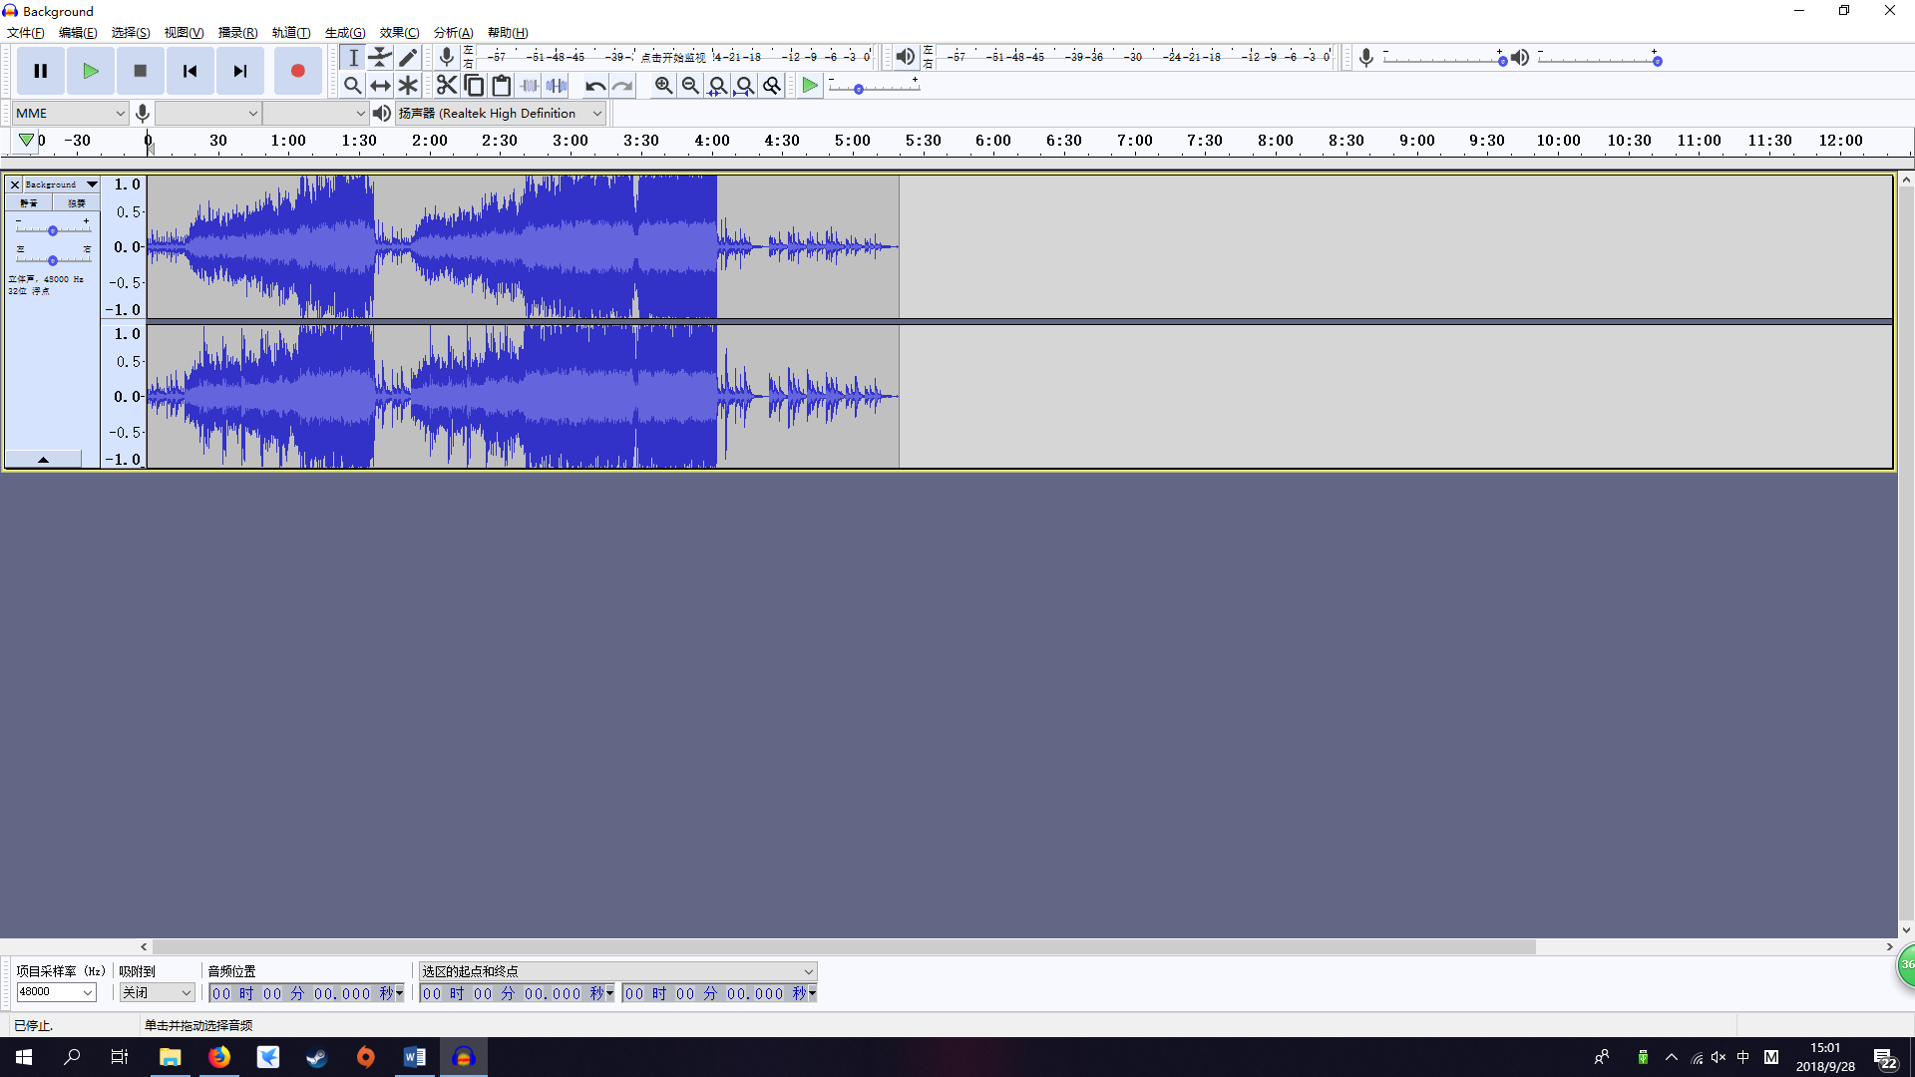

Light bulb

For this sound effect will be used as the streetlight, which I use my phone recorded from one of the broken street light around my house and used audacity to export into mp3 format.

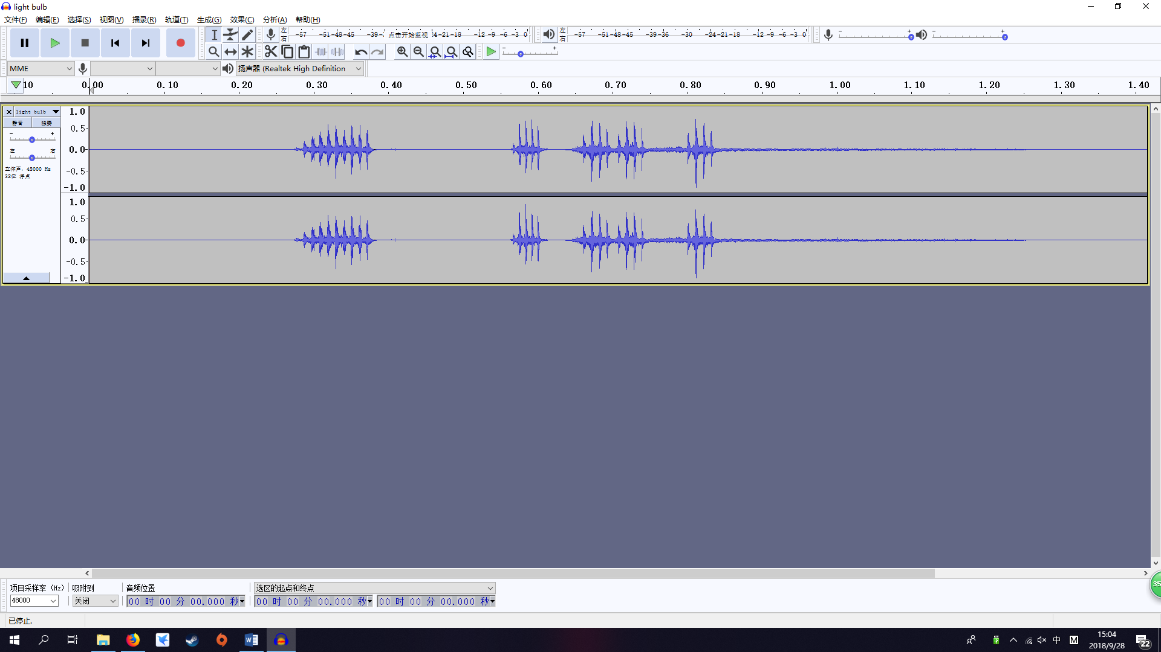

Footsteps

For this sound effect was created by my phone through recording from myself walking on the wood ground with shoes.

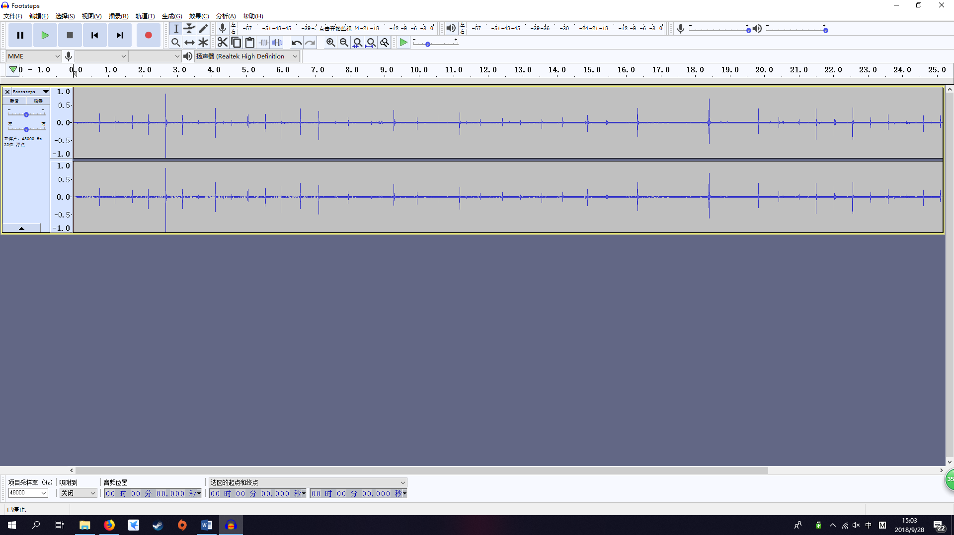

Car start engine

For this sound effect was created by my phone through recording from my car engine.

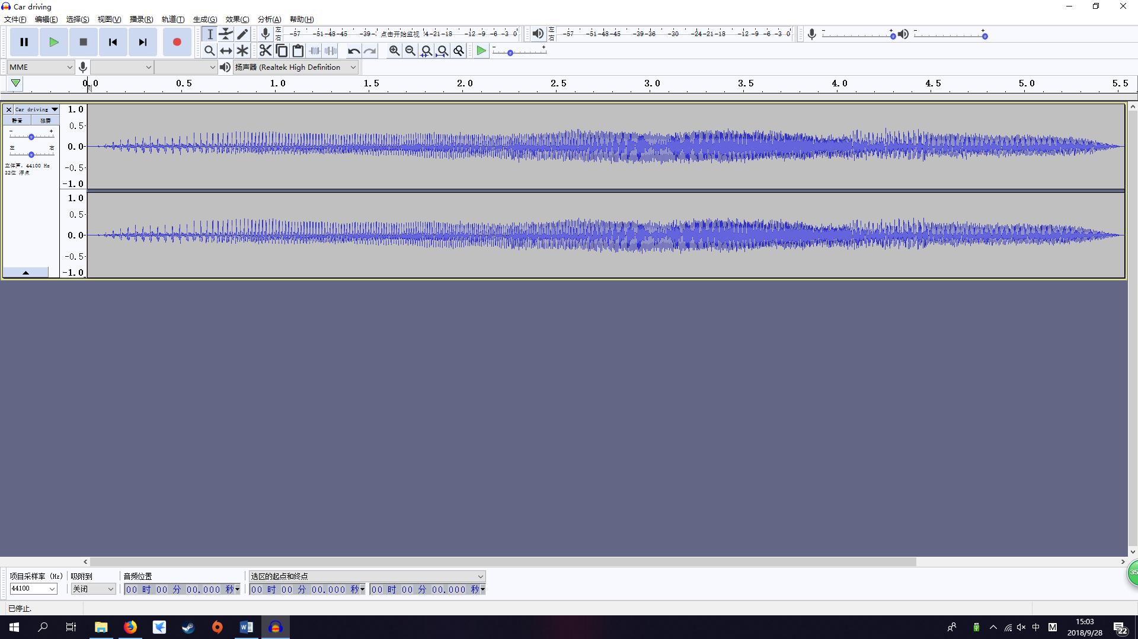

Car driving

For this sound effect was created by my phone through recording from my car while my friend was driving it.

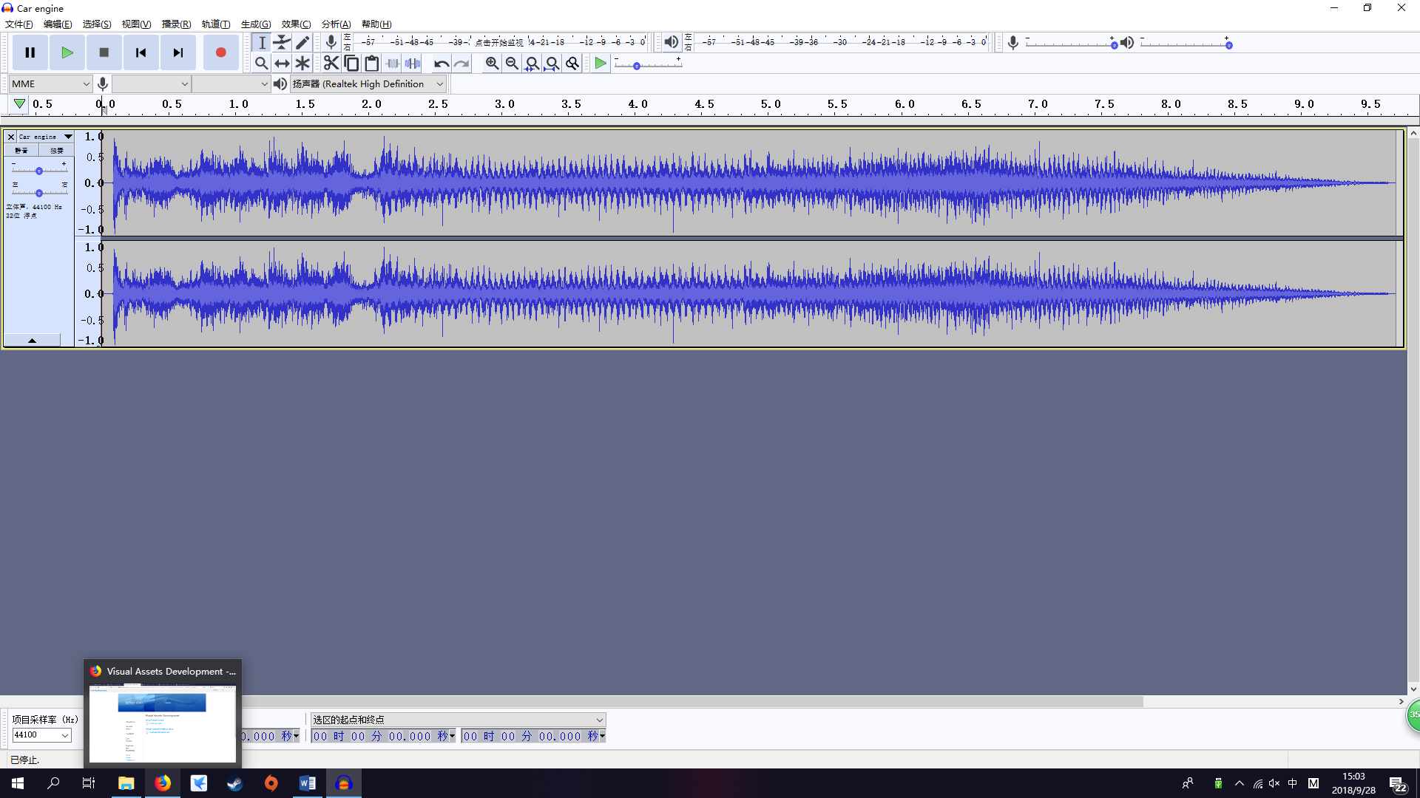

Bird

For this sound effect was created by my phone through recording from the bird around my house on the morning.

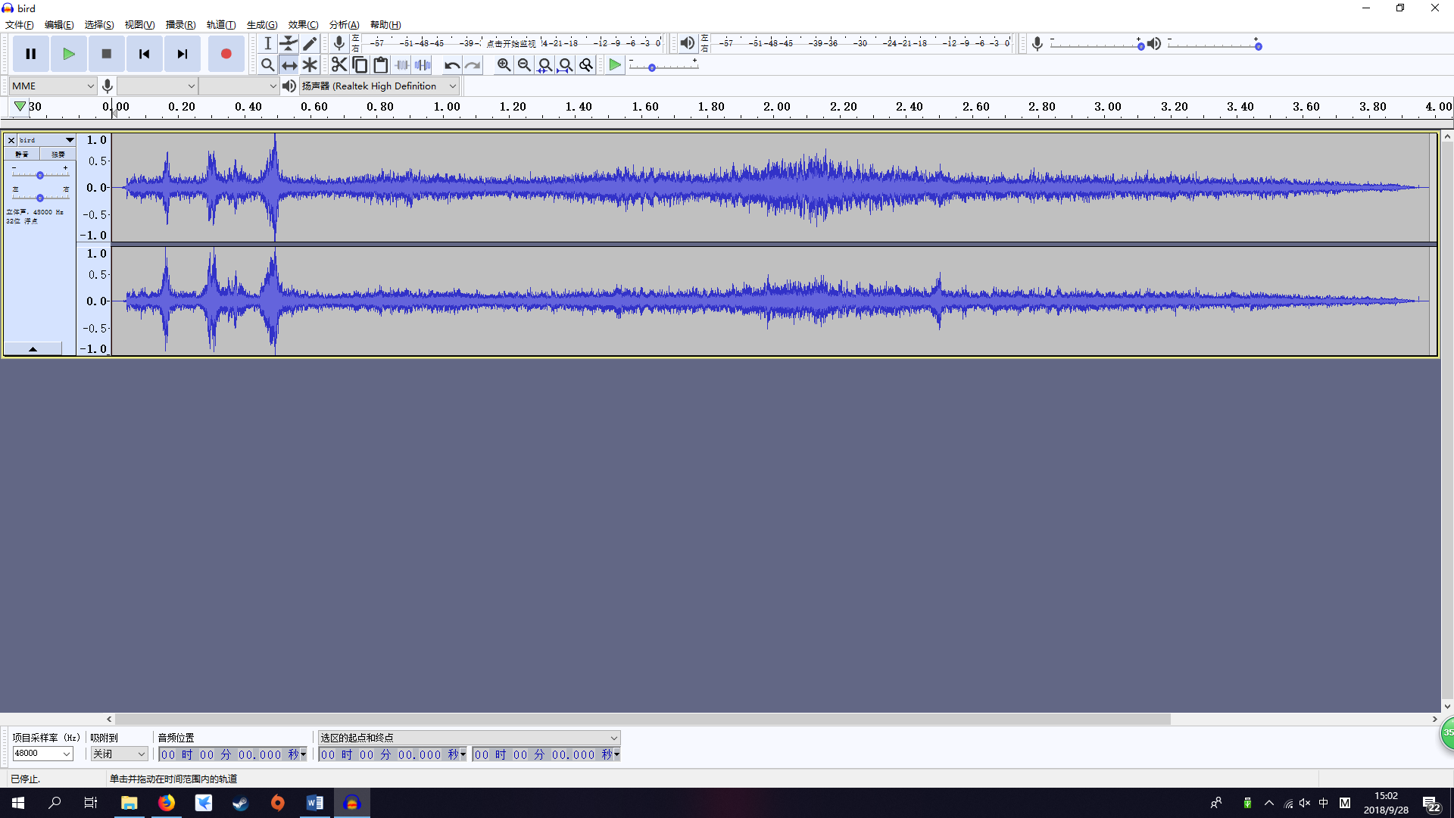

Pick up

For this sound effect was created by my phone through recording from myself picking up an object.

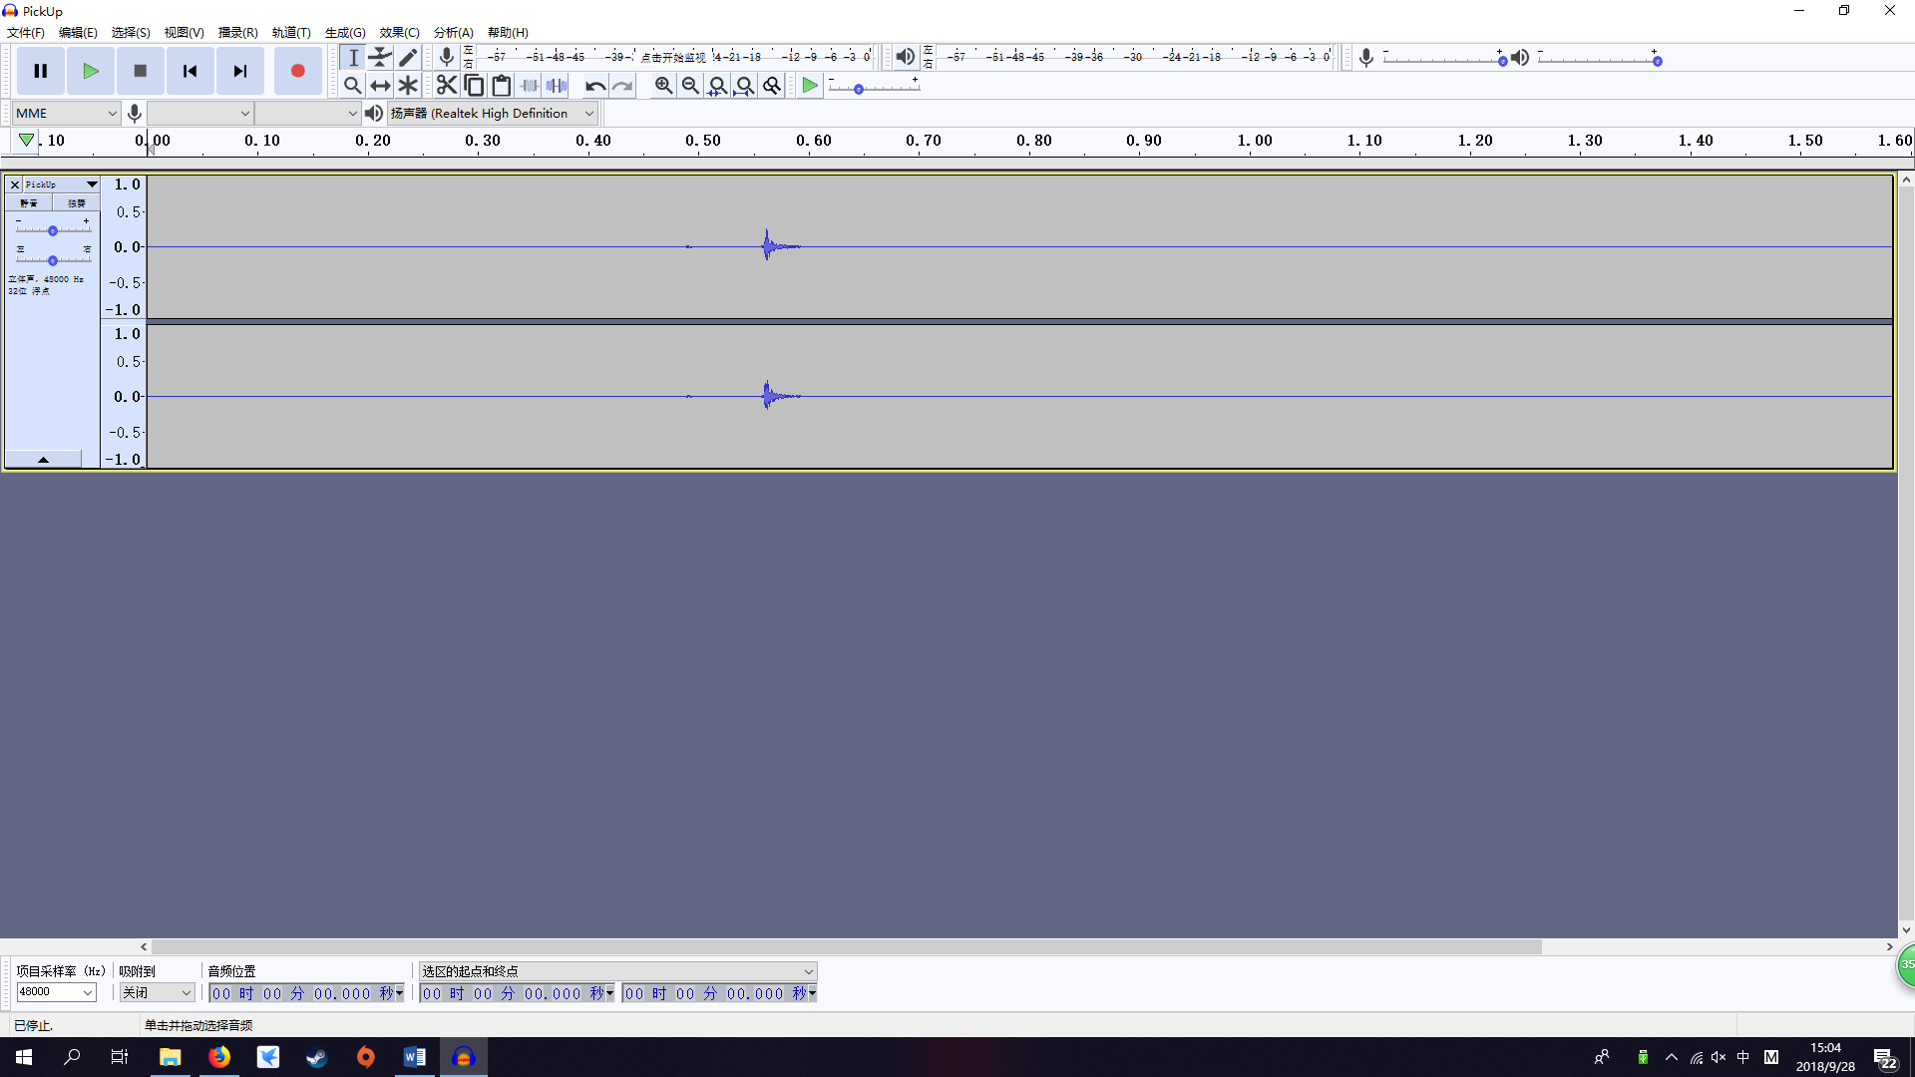

Drop

For this sound effect was created by my phone through recording from myself dropping a box.

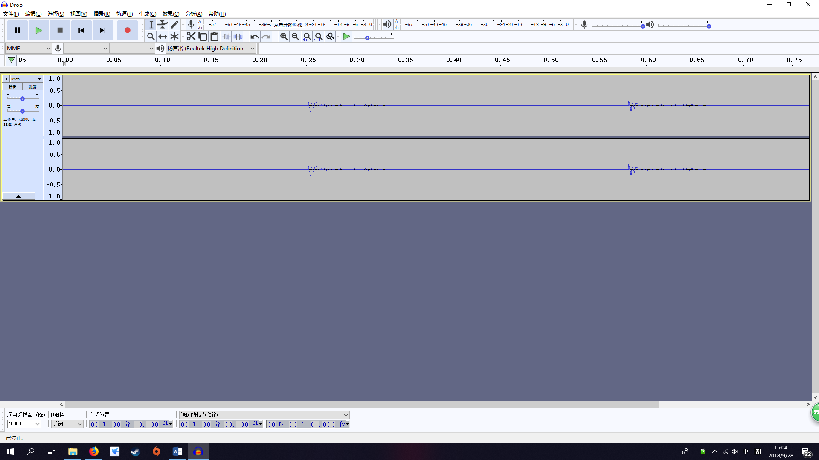

Welcome sounds effects

For this sounds effect was download from YouTube, which will use in the scene when user enter the scene.

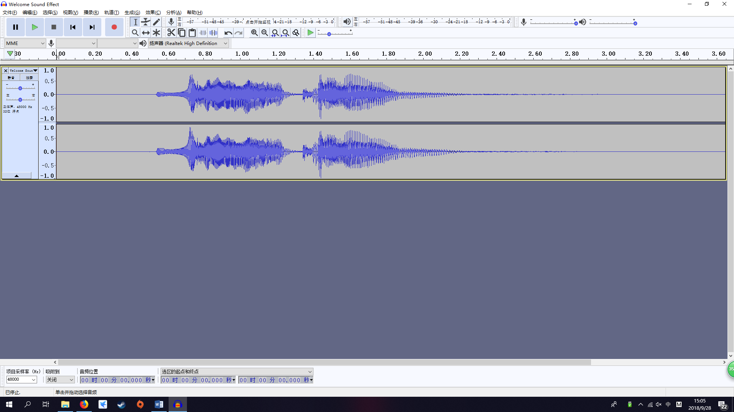

Wind

For this sound effect was created by my phone through recording from the real wind sound. The sound will be looping with longer waiting to repeat time.

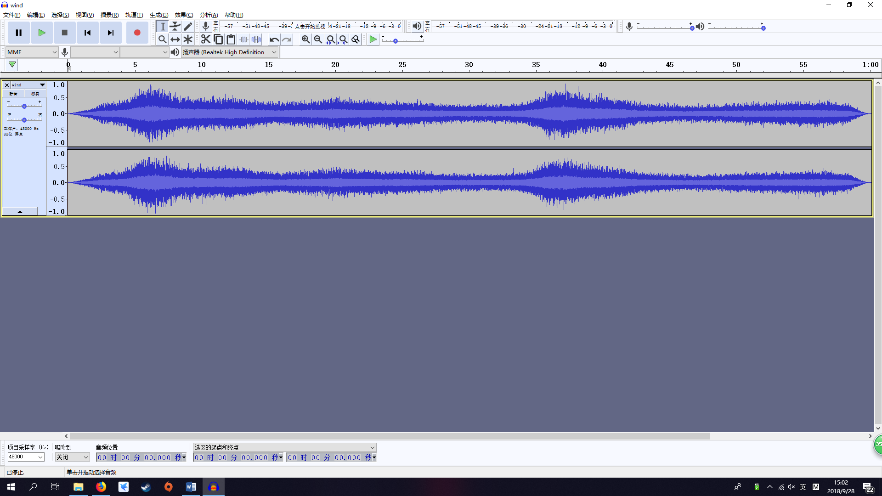

**Reference:**

HDSounDI, 2016*. Most Beautiful Music Ever: "Everdream" by Epic Soul Factory*, youtube.com. Retrieved from 27 Sept 2018

<<https://www.youtube.com/watch?v=8DSeZji2x-Y> >

Free Sound Effects. 2017. *Welcome Sound Effect*. Youtube.com. Retrieved from 27 Sept 2018

<<https://www.youtube.com/watch?v=vtihy-enOsY&t=8s> >